Adding the Extension to SQLDeveloper
The final step is to add a new tab to SQLDeveloper, showing the CRUD details for each table.
The first step is to create the crud.xml file, which looks like this :
<items>
<item type="editor" node="TableNode" vertical="true">
<title><![CDATA[CRUD]]></title>
<query>
<sql>
<![CDATA[SELECT object_owner, object_name, object_type, create_flag, read_flag, update_flag, delete_flag
FROM crud_owner.db_crud
WHERE table_owner = :OBJECT_OWNER
AND table_name = :OBJECT_NAME
ORDER BY object_name, object_type, object_owner]]>
</sql>
</query>
</item>
</items>

Now we need to add the user-defined extension to SQLDeveloper.
Open SQLDeveloper and select the Tools/Preferences menu.
In the tree on the left of the dialog box, open the Database node and select User Defined Extensions.
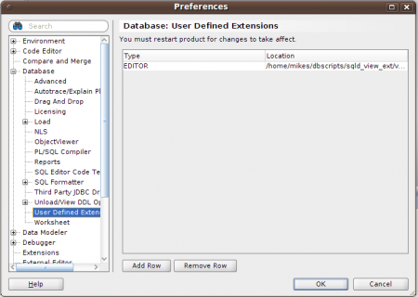
Defining a new User Defined Extension in SQLDeveloper
Click the Add Row button.
Click in the Type field and select Editor from the drop down.
Click Browse and select the crud.xml file
Click Save, then Click OK.
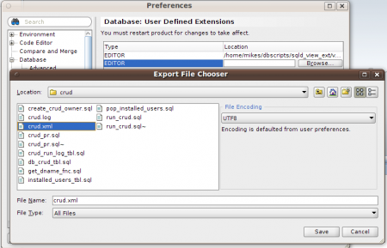
Enter the location of the xml file
Now re-start SQLDeveloper, when you go back in, you should see a new tab in the tables view …
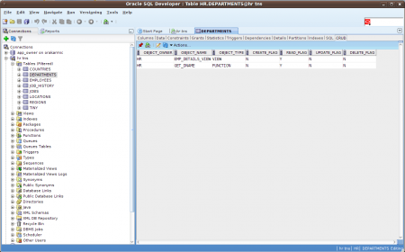
CRUD, glorious CRUD !
I did wonder whether I should put this onto SourceForge, but, given the distinct absence of comments from my first post, I suspect it’s not exactly widely used and to do so would therefore be something akin to vanity publishing.
If you do feel inclined to give it a whirl please let me know how you get on.
Right now, I’m going to get back to the cricket. England seem to be beating everyone they should lose to and losing to everyone they should beat. At least it’s not dull !

